**Template Heads of Terms**

**General Notice**

1. This is a standard template document and may not be suitable in all circumstances.
2. No template can be definitive, and all templates can be improved.
3. If you have any queries or are unsure about whether to use this template, please call our Commercial Property team on **0161 941 4000** or email [**lawyers@myerson.co.uk**](mailto:myersonHR@myerson.co.uk), and a member of the team will be happy to assist you.

0161 941 4000 | myerson.co.uk | [lawyers@myerson.co.uk](mailto:lawyers@myerson.co.uk)

**Template Heads of Terms**

**[ADDRESS OF PROPERTY]**

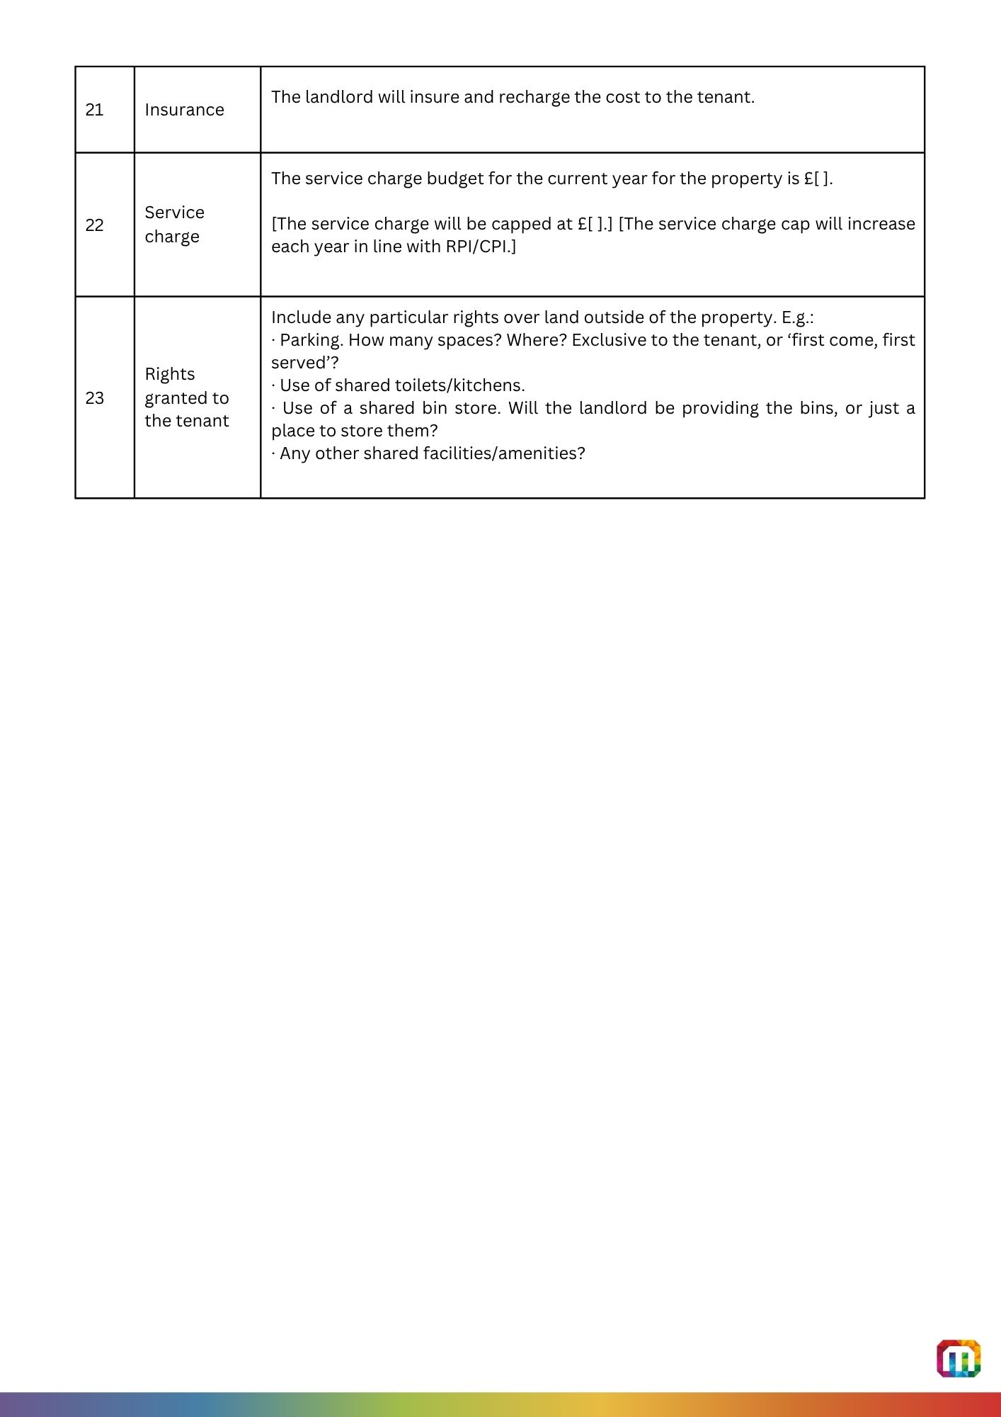[DATE]

|  |  |  |
| --- | --- | --- |
|  | Landlord | Full legal name  Address  Contact name/email address/telephone number |
|  | Landlord’s agent | Firm/company name  Address  Contact name/email address/telephone number |
|  | Landlord’s solicitor | Firm  Address  Contact name/email address/telephone number |
|  | Tenant | Full legal name  Address  Contact name/email address/telephone number |
|  | Tenant’s agent | Firm/company name  Address  Contact name/email address/telephone number |
|  | Tenant’s solicitor | Firm  Address  Contact name/email address/telephone number |
|  | Guarantor | Full legal name  Address  Contact name/email address/telephone number |
|  | Property | [Address]  Describe situation, e.g. a unit within a building, a warehouse on an estate, a shop within a shopping centre, etc. |
|  | Conditions | List any conditions, e.g. obtaining head landlord’s consent, works the landlord must first complete, etc. |
|  | Term | [ ] years. |
|  | Break clauses | Who can break – landlord, tenant or both?  Break dates: specify dates or, for a rolling break, ‘at any time on or after’.  The tenant must give not less than [ ] months’ notice.  The break is unconditional.  OR  The break is conditional on there being no arrears of annual rent, the tenant giving up occupation, and there being no other occupiers or subsisting subleases. |
|  | Security of tenure | Yes/no. |
|  | Annual rent | £[ ] per year exclusive of VAT. |
|  | Rent concessions | Describe any rent free or reduced rent period. |
|  | Rent deposit | The tenant will pay a rent deposit of £[ ], which is equivalent to [ ] months’ rent plus VAT.  The rent deposit will be held [for the whole term] OR [provide details of early release]. |
|  | Rent review | Rent review dates:  An upward only, open market rent review.  OR  An upward only rent review, index linked to RPI/CPI [compounded annually].  In either case – include any minimum and/or maximum rent increase. |
|  | Permitted use | Use as [ ] within Use Class [ ]. |
|  | Repair | The tenant must keep the property in good and substantial repair [subject to a photographic schedule of condition, which is to be annexed to the lease].  [If the tenant is to benefit from construction warranties, include information here.] |
|  | Dealing with the lease | |  |  |  |  | | --- | --- | --- | --- | | **Dealing** | **Permitted?\*** | | | | **N** | **CNBW** | **Y** | | Assign whole |  | X |  | | Assign part | X |  |  | | Sublet whole |  | X |  | | Sublet part | X |  |  | | Charge whole (fixed charge) |  | X |  | | Charge whole (floating charge) |  |  | X | | Group sharing |  |  | X |   * **N** means prohibited.  **CNBW** means ‘permitted with landlord’s consent, which is not to be unreasonably withheld or delayed’.  **Y** means permitted without landlord’s consent. |
|  | Alterations | |  |  |  |  | | --- | --- | --- | --- | | **Type of alteration** | **Permitted?\*** | | | | **N** | **CNBW** | **Y** | | External structural | X |  |  | | External non-structural | X |  |  | | Internal structural | X |  |  | | Internal non-structural |  | X |  | | Internal demountable partitioning |  |  | X |   * **N** means prohibited.  **CNBW** means ‘permitted with landlord’s consent, which is not to be unreasonably withheld or delayed’.  **Y** means permitted without landlord’s consent.  [The tenant’s fit out will be documented by a licence to alter.] |
|  | Insurance | The landlord will insure and recharge the cost to the tenant. |
|  | Service charge | The service charge budget for the current year for the property is £[ ].  [The service charge will be capped at £[ ].] [The service charge cap will increase each year in line with RPI/CPI.] |
|  | Rights granted to the tenant | Include any particular rights over land outside of the property. E.g.:   * Parking. How many spaces? Where? Exclusive to the tenant, or ‘first come, first served’? * Use of shared toilets/kitchens. * Use of a shared bin store. Will the landlord be providing the bins, or just a place to store them? * Install and/or connect to air-conditioning or other external plant? * Any other shared facilities/amenities? |

